**What to find?**

1. Pet Category (Classification - 0, 1, 2, 4)
2. Breed Category (Classification - 0, 1)

**EDA:**

1. Scatter Plot - Pet Category vs Breed Category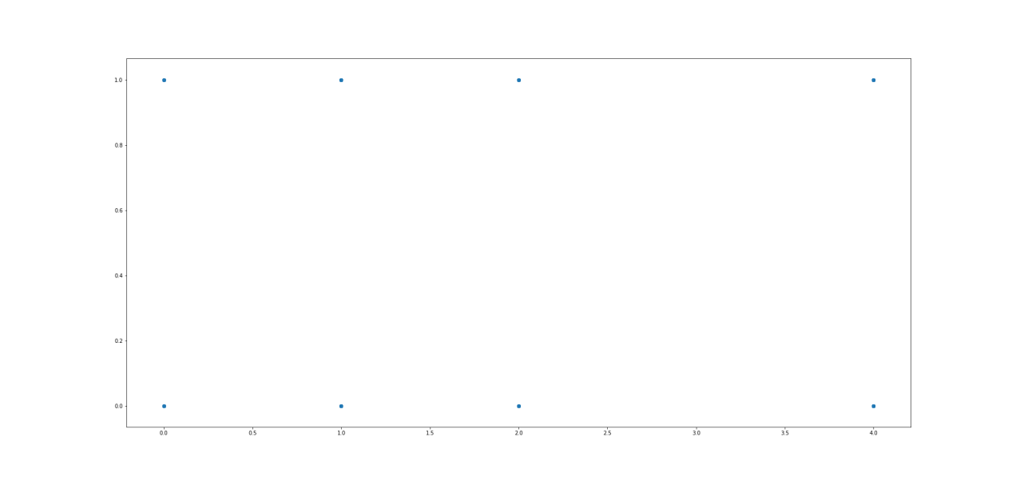
2. Scatter Plot - Pet Category vs Color Type(not selected)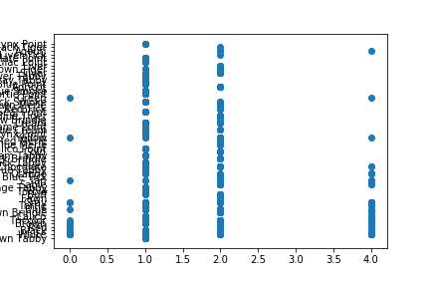This gave a very big bump in accuracy of about 30%.
3. Scatter Plot - Pet Category vs Height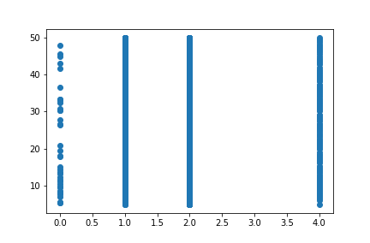

This seems to be of some use as categories 1 and 2 take all values clearly while category 0 is quite discrete. Category 4 is quite like 1 and 2 except for some very small gaps.

1. Scatter Plot - Pet Category vs Condition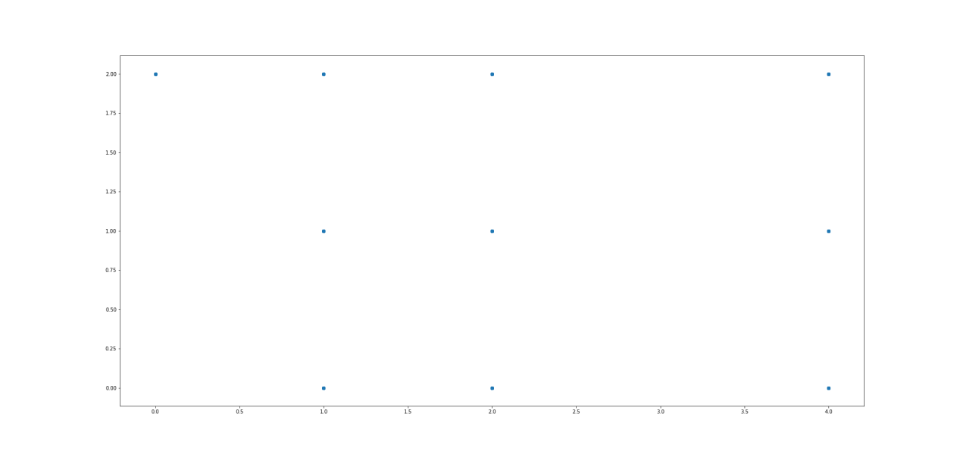
2. Scatter Plot - Pet Category vs Length(m)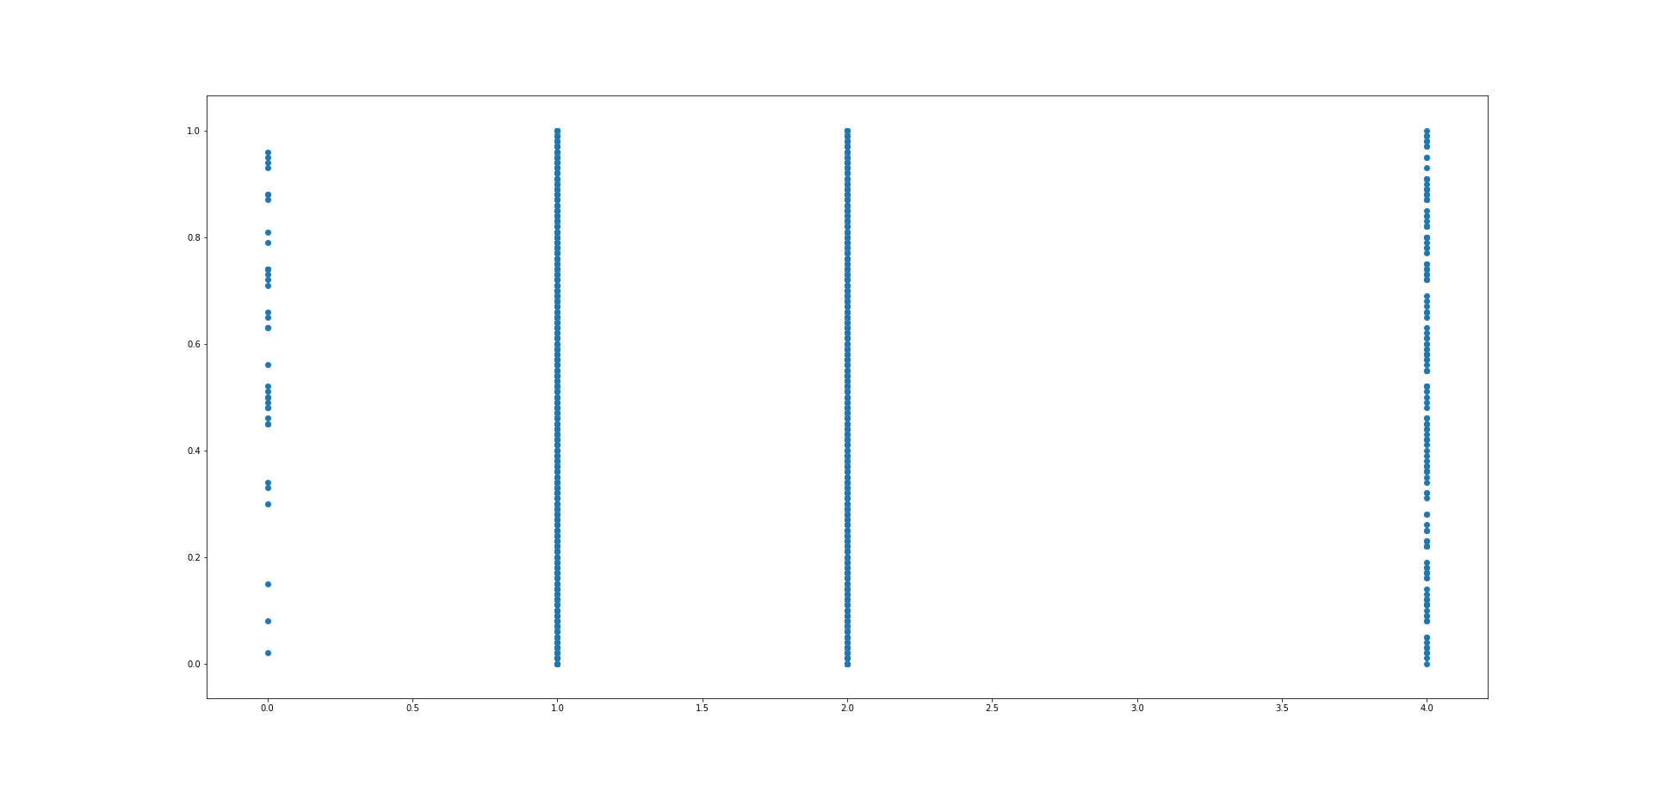Similar to Height and Color type, Pet Category 1 and 2 are almost indistinguishable while category 4 is quite close category 0 is very differing.

**No one feature is enough to distinguish all Pet categories and therefore a combination of some kind is required to classify them.**

Columns :

Independent (X) = 3, 5, 6, 7, 8

Dependent (y) = 9, 10

Training Size - 70%

Classifiers:

Logistic Regression, KNN, Random Forest, Bayes Theorem